

DEV-1 PROJECT

**DESIGN A WEB SCRAPER TO SCRAPE DATA FROM A WEBSITE , ANALYZE THE DATA AND MAKE A REPORT ON THE ANALYSIS.**

SUBMITTED BY- SAKSHI MITTAL (045049)

PGDM(BDA-04)

SUBMITTED TO - PROF AMARNATH MITRA

DATA SOURCE

Website- “[McDonald's - Wikipedia](https://en.wikipedia.org/wiki/McDonald%27s)”

The Data in the above website is related to McDonald which contains its financial information like Revenue , Net Income , Total Assets etc from 2005 to 2021 .

OBJECTIVES

* One of the objectives is to provide a historical overview and snapshot of McDonald's performance and key metrics over time.
* It can be useful for various purposes, such as financial analysis, trend analysis, and benchmarking.
* Top of Form
* It helps Stakeholders including investors, analysts, and researchers to assess McDonald's financial health, profitability, and growth over the years.
* The insights from the data can guide strategic planning for the future. It can help in setting growth targets, resource allocation, and making decisions in order to increase its financial and operating profits.

LIBRARIES USED

* from bs4 import BeautifulSoup
* import requests
* import pandas as pd
* import numpy as np
* import matplotlib.pyplot as plt
* from scipy import stats
* import seaborn as sns

COLUMNS IN THE TABLE

* Year
* Revenue (in million US$)
* Net Income (in million US$)
* Total Assets (in million US$)
* Price Per Share (in US$)
* Locations
* Employees

Analysis

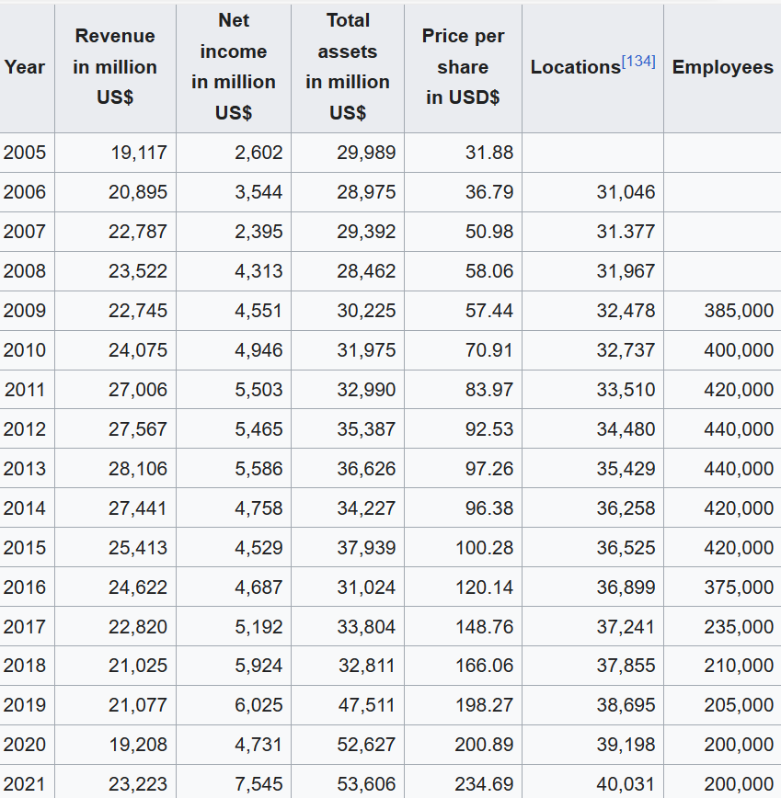

Revenue and Net Income:

McDonald's revenue has generally shown an upward trend from 2005 to 2021, with some fluctuations. It reached its highest point in 2021 at $23,223 million.

Net income has also seen an overall increase over the years, with the highest net income recorded in 2021 at $7,545 million.

Total Assets:

Total assets have fluctuated but generally increased over the years. In 2021, total assets amounted to $53,606 million.

Price per Share:

The price per share of McDonald's stock has shown an increasing trend, with the highest price per share recorded in 2021 at $234.69 USD.

Locations:

The number of McDonald's locations appears to have increased steadily, with a peak in 2021 at 40,031 locations.

Employees:

The number of employees at McDonald's remained relatively stable, with the highest reported number at 440,000 in 2013 and 2014. There was a significant decrease in 2017 to 235,000, but it appears to have increased again in later years.

Top of Form

Basic Statistics of the data

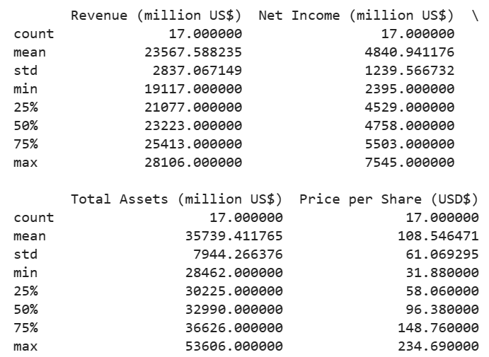

* **Revenue and Net Income:** The average annual revenue for McDonald's over the 17-year period is approximately $23,568 million, with a standard deviation of approximately $2,837 million, indicating moderate variability. The average annual net income is approximately $4,841 million, with a standard deviation of approximately $1,240 million**.**
* **Total Assets:** The average total assets held by McDonald's over the 17-year period is approximately $35,739 million, with a standard deviation of approximately $7,944 million. This indicates significant variability in the total assets**.**
* **Price per Share:** The average price per share of McDonald's stock over the 17-year period is approximately $108.55 USD, with a standard deviation of approximately $61.07 USD. This shows substantial variability in the stock price.

When Data is Sorted by Revenue



* 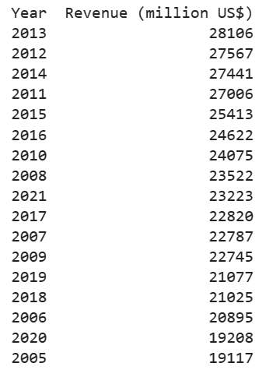**Maximum Revenue was earned in year 2013**
* **Minimum Revenue was earned in year 2005**

When Data is Sorted by Net Income



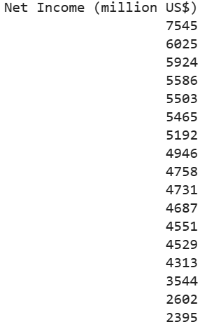

* Maximum Net Income was earned in 2021
* Minimum Net Income was earned in 2007

When Data is Sorted by Total Assets



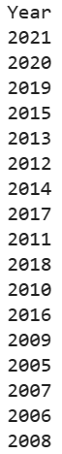 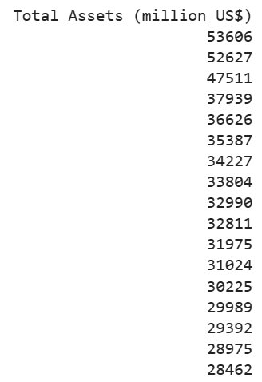

* Maximum Total Assets was earned in 2021
* Minimum Total Assets was earned in 2008

When Data is Sorted by Prices Per Share



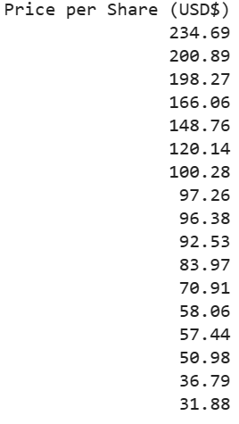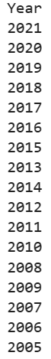

* Maximum Prices per share was earned in 2021
* Minimum Prices per share was earned in 2005

Calculating Mean , Median , Mode , Standard Deviation and Variance

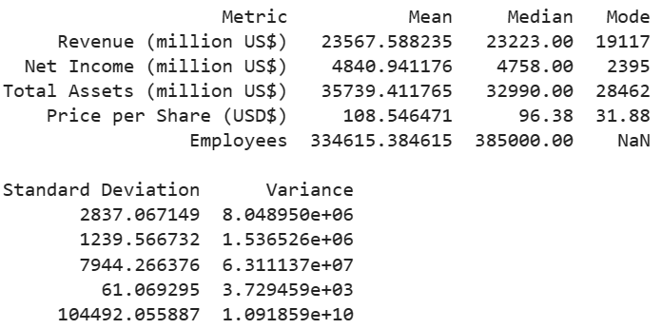

These statistics provide insights into various aspects of McDonald's financial performance and operations over the 17-year period. It's notable that revenue and net income have generally increased, while total assets have shown significant variability. The price per share has also fluctuated, reflecting changes in market conditions. The employee count has varied, with a median of 385,000 employees

Data Visualization

1.Creating Stacked Bar Chart

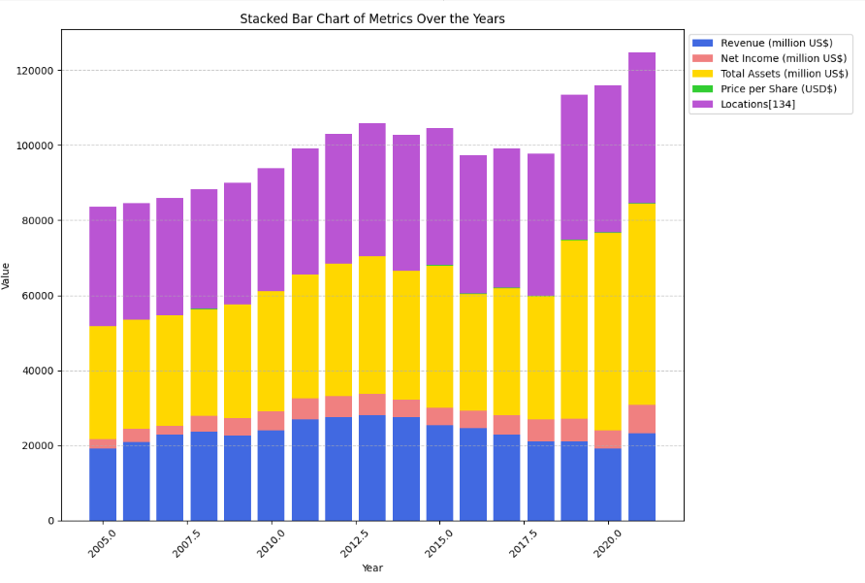

In stacked bar chart , we are comparing Revenue , Net Income , Total Assets , prices per shares and locations from 2005 to 2020 such as Revenue is highest in 2013 , Net income in 2021 and so on.

2.Creating Pie Chart to Show Revenue Distribution

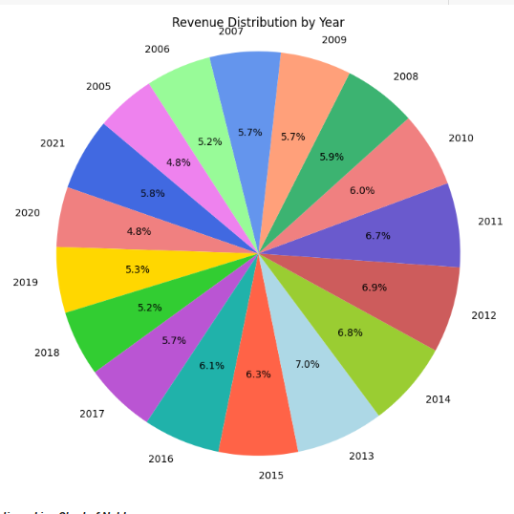

Through Pie Chart , we are showing the revenue distribution from 2005 to 2021 and from this , we are inferring that Revenue is highest in 2013 (7%) and lowest in 2005(4.8%)

3.Creating a Line Chart for Net Income

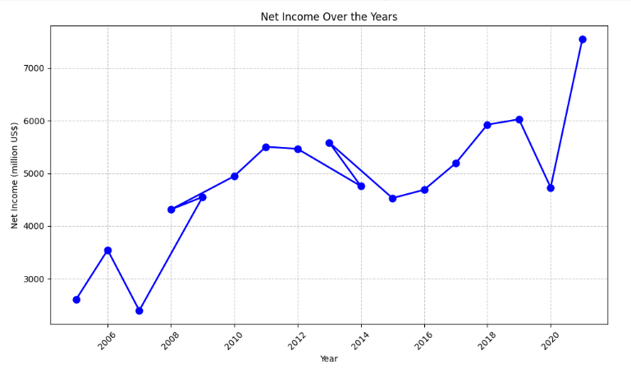

Through Line Chart , we are showing the Net Income distribution from 2005 to 2021 and from this , we are inferring that Net Income is highest in 2021 (7545) and lowest in 2005(2602).

4.Creating a Boxplot for Total Assets

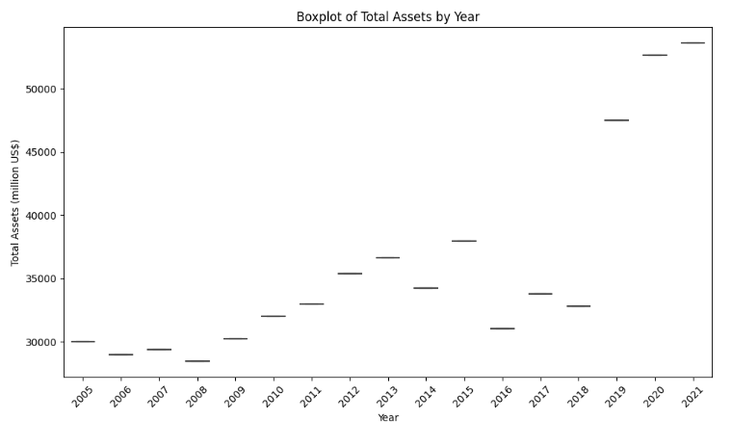

Through Boxplot , we are showing the Total Assets Distribution from 2005 to 2021 and from this , we are inferring that Total Assets are highest in 2021 (53606) and lowest in 2008(28462).

5.Creating a Bar Chart for Prices Per Share

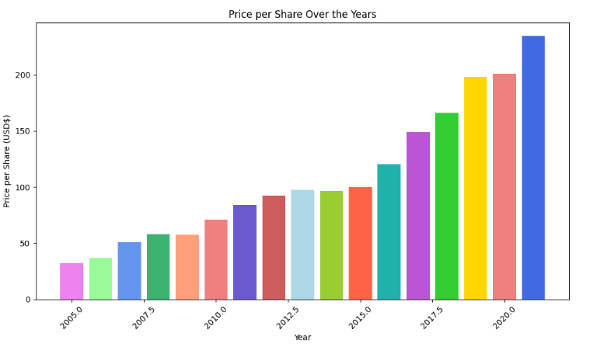

Through Bar chart , we are showing the Prices Per Share Distribution from 2005 to 2021 and from this , we are inferring that Prices Per Share are highest in 2021 (234.69) and lowest in 2005(31.88).

Correlation Analysis

1.Correlation between Revenue and Net Income

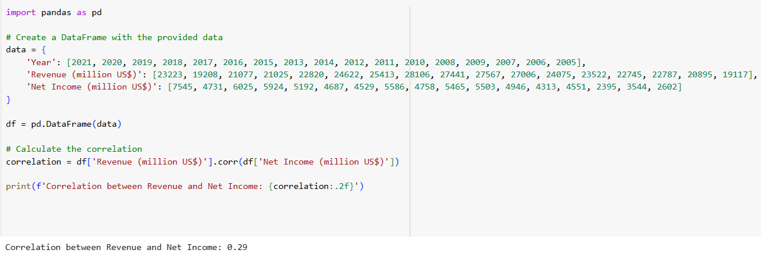

The correlation coefficient of 0.29 between Revenue and Net Income suggests a positive but relatively weak linear relationship between these two variables. In other words, as McDonald's revenue increases, there is some tendency for its net income to also increase, but the correlation is not very strong.

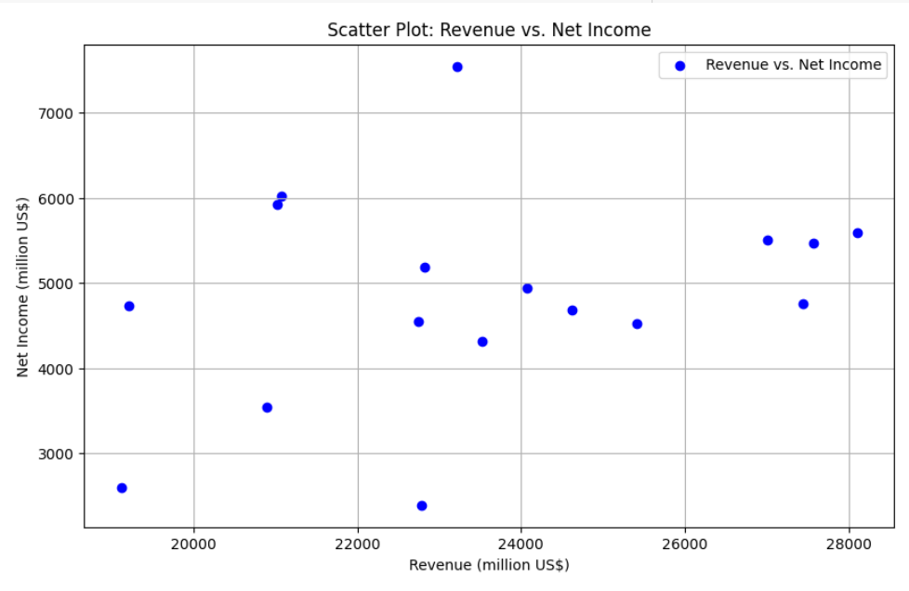

2.Correlation between Total Assets and Prices Per Share

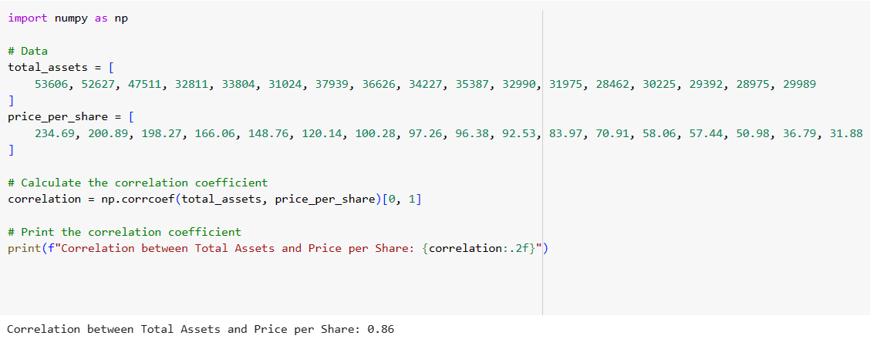

The correlation coefficient of 0.86 between Total Assets and Price per Share indicates a strong positive linear relationship between these two variables. In simple terms, as McDonald's total assets increase, there is a strong tendency for its stock price (price per share) to also increase.

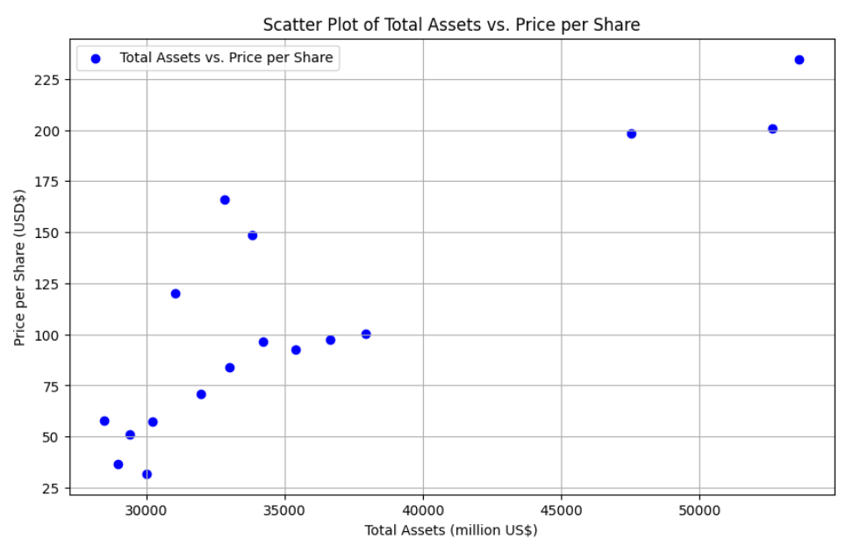

Profitability and Efficiciency Ratios

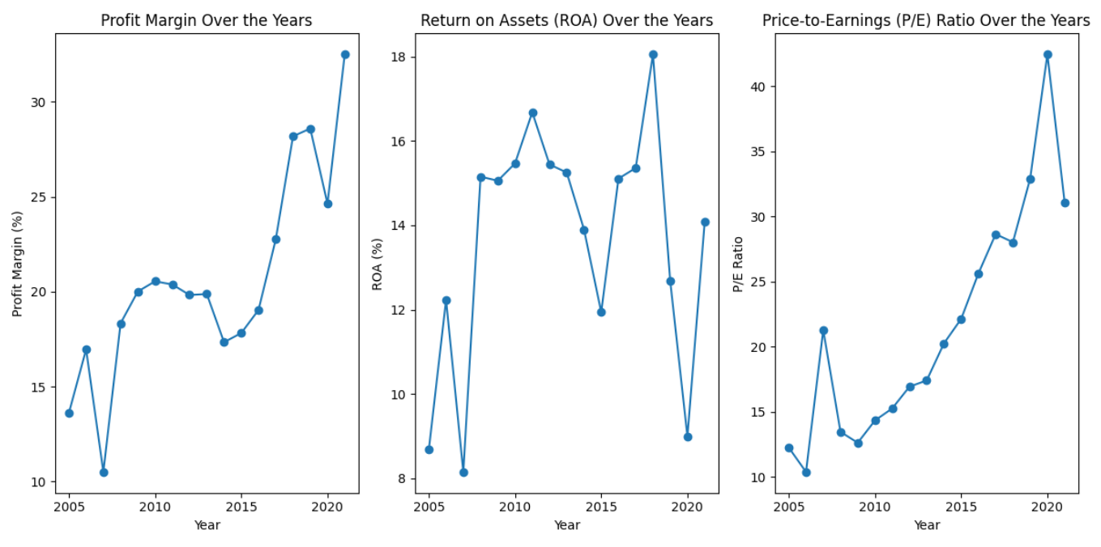

1.Profit Margin : The trend in the plot shows that McDonald's profit margin has generally fluctuated over the years, with some ups and downs. There was a noticeable increase in profit margin from around 2010 to 2012, indicating improved profitability during that period. Overall, the profit margin appears to have maintained a relatively stable range.

2. Return on Assets: The plot shows that McDonald's ROA has also fluctuated, with periods of improvement and decline. There was a notable increase in ROA from around 2010 to 2012, suggesting that McDonald's was more effective in generating profit from its assets during that period. Similar to the profit margin, ROA has remained within a relatively consistent range over the years.

3. Price to Earnings Ratio: The plot reveals that McDonald's P/E ratio has generally increased over time, indicating that investors have been willing to pay more for each dollar of earnings. The P/E ratio tends to be higher in recent years, suggesting increased investor optimism about the company's future earnings potential.

Employee Analysis

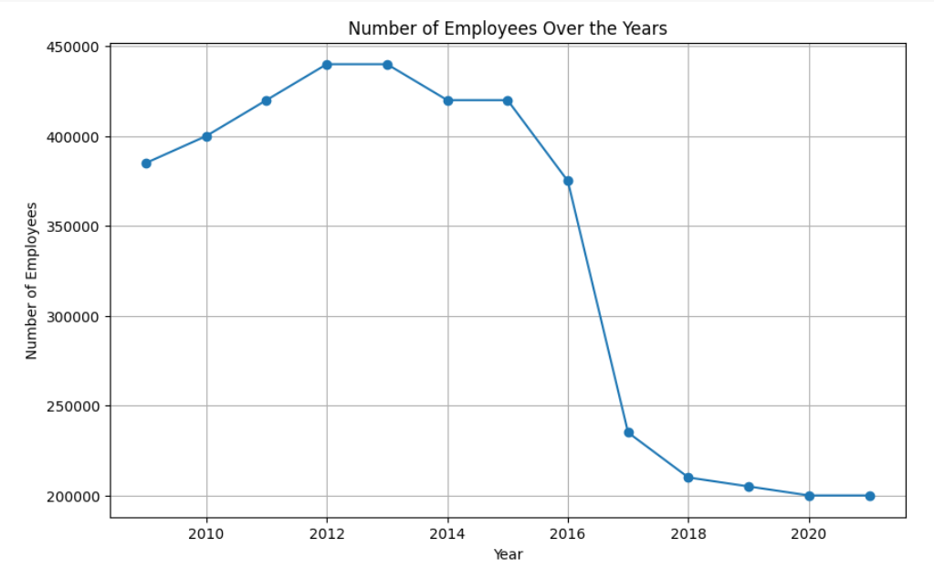

Through the above Line Chart , we are showing the number of employees from 2005 to 2021 and from this , we are inferring that the number of employees are highest in 2012 and 2013 (440000) and lowest in 2020 and 2021 (200000).

1. Revenue Per Employee

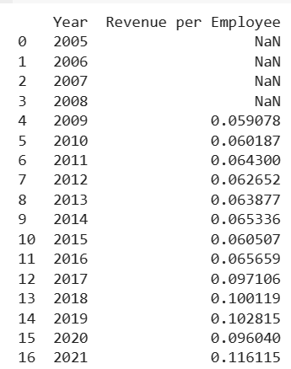

Starting from 2009, there is a noticeable trend of increasing revenue per employee.

The ratio shows steady growth from 2009 to 2015, indicating improved revenue generation relative to the number of employees. There is some fluctuation in the following years, but the ratio continues to increase, reaching its highest point in 2021.

The substantial increase in revenue per employee from 2017 onwards suggests that McDonald's has become more efficient in generating revenue with its existing workforce.

Location Analysis

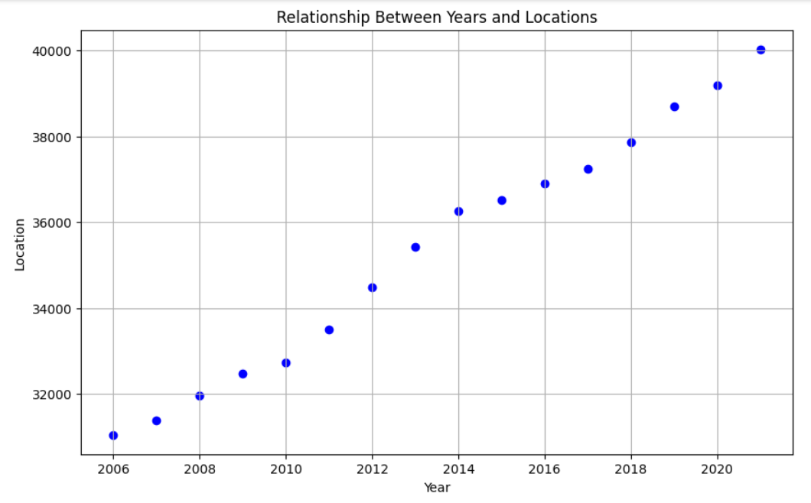

Through the above Scatter Plot , we are showing the number of locations from 2005 to 2021 and from this , we are inferring that the number of employees are highest in 2021 (40000) and lowest in 2006 (31046).

Correlation Between Location and Other Metrics

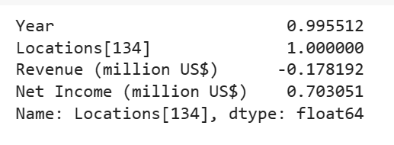

* Year and Locations: The correlation coefficient of approximately 0.9955 indicates an extremely strong positive linear relationship between the "Year" and "Locations" . This suggests that the number of McDonald's locations has consistently increased over the years.
* Revenue and Net Income: The correlation coefficient of approximately 0.7031 between "Revenue (million US$)" and "Net Income (million US$)" indicates a moderately strong positive linear relationship. This implies that as McDonald's revenue increases, there is a tendency for its net income to also increase, suggesting that the company has been profitable.
* Year and Revenue: The correlation coefficient of approximately -0.1782 between "Year" and "Revenue (million US$)" suggests a weak negative linear relationship. This indicates that there may be a slight decrease in revenue over the years, but the correlation is not very strong.

Creating Heatmap to show Correlation

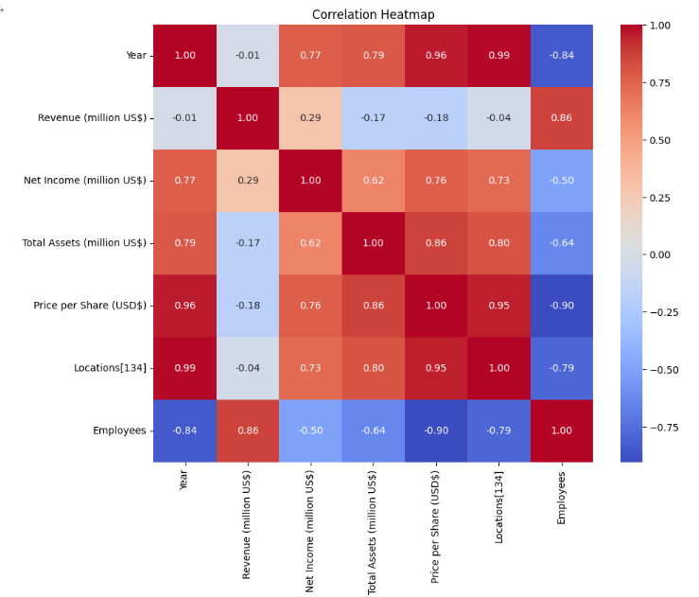

* "Revenue (million US$)" and "Net Income (million US$)" show a strong positive correlation, indicating that higher revenue is associated with higher net income.
* "Price per Share (USD$)" has a negative correlation with "Year," suggesting that the price per share tends to decrease over the years.
* "Total Assets (million US$)" and "Locations[134]" exhibit a positive correlation, suggesting that as the number of locations increases, total assets tend to increase.

Calculating Annual Growth Rate

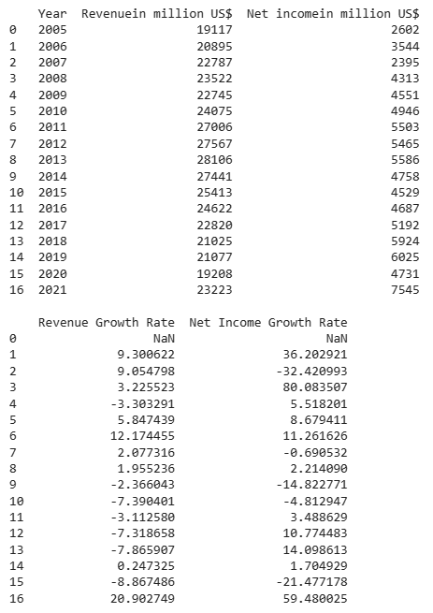

1.Revenue Growth Rate: In 2006, McDonald's experienced a significant positive growth rate of approximately 9.30%, indicating a strong increase in revenue compared to the previous year. The growth rate fluctuated in subsequent years, with some positive and negative values. Notably, there was a significant negative growth rate in 2015 (-7.39%), suggesting a decrease in revenue that year. The growth rate spiked in 2021, reaching approximately 20.90%, indicating a substantial increase in revenue compared to the previous year.

2.Net Income Growth Rate: In 2008, there was a significant positive growth rate of approximately 80.08%, indicating a substantial increase in net income compared to the previous year. However, in 2015 and 2018, there were negative growth rates, suggesting decreases in net income in those years. The net income growth rate reached its highest point in 2021, with a growth rate of approximately 59.48%, indicating a significant increase in net income compared to the previous year.

Managerial Insights

1. McDonald's financial performance and stability, highlighting its consistent revenue generation and profitability. The substantial variability in total assets and stock price underscores the importance of managing and optimizing these aspects for sustainable growth.
2. McDonald's financial and operational metrics allowing stakeholders to understand the company's financial performance, stability, and workforce size. The variability in some metrics, such as total assets and stock prices, highlights the need for effective management and strategic planning.
3. Relying solely on revenue growth may not guarantee a proportional increase in net income. Diversifying revenue streams or optimizing existing ones could help improve profitability independently of revenue changes.
4. The weaker correlation suggests that McDonald's net income is influenced by factors beyond just revenue. Understanding these factors and managing associated risks is vital for maintaining consistent profitability.
5. Efficiently managing and growing the company's assets can have a direct impact on its stock price. Strategic investments and asset utilization are crucial for enhancing shareholder value.
6. McDonald's Return on Assets (ROA) has experienced periods of improvement and decline. The notable increase in ROA from 2010 to 2012 suggests that the company was more efficient in generating profit from its assets during that time. Ensuring optimal asset utilization is crucial for maximizing profitability.
7. The noticeable increase in profit margin from 2010 to 2012 indicates improved profitability during that period. Maintaining a consistent profit margin is essential for long-term financial sustainability.
8. The increasing Price-to-Earnings (P/E) ratio reflects growing investor optimism about McDonald's future earnings potential. Investors have been willing to pay a higher price for each dollar of earnings, indicating confidence in the company's growth prospects. Maintaining transparency and meeting investor expectations are key to sustaining this confidence.
9. McDonald's should focus on understanding the factors contributing to fluctuations in revenue and net income growth rates. It's important to identify strategies that can sustain or improve growth rates and address challenges during periods of decline which helps in future financial planning and decision-making to drive continued growth and profitability.